Mini-Project 2: Motion Analysis and Plotting

Lab Report

Name: Jiawei Zhu

Student ID Number: 923312684

Instructions
Download this lab report template and complete each section. Be sure to include this cover page along with your report. Upload your plots by copy-pasting them into this document. Submit a pdf of your completed lab report to Canvas by the deadline.

You may submit as many times as you wish up until the deadline. However, late submissions are not accepted. Questions begin on the following page and there is one question per page. When uploading your submission, do not change the order of questions or answer more than one question per page. Doing so may cause your submission to be imported incorrectly.

Note: it is a violation of academic integrity to submit code written by someone else or plots produced by someone else or by using another person’s code.

Question 1: Summary of the Project
In your own words, write a short summary of what was done for this project.

This project takes me a lot of time. And what we did differently from Project is that we added more graphs (X Acceleration, Y Acceleration, Z Acceleration, and Resultant Acceleration). And after collecting, we need to save it in the file named sensorData.mat.

Then, the next step is data analysis. We need to make a new script called dataAnalysis.m. Using load to read what I wrote before, and using the formula to calculate the Resultant Acceleration.
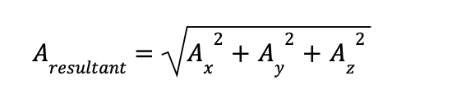
And we need to use subplot for that to make the box plot exchange in 1*4. And for the first time, I made the plot 2*2, after the TA’s instruction, it was fixed.

And the last step is to find the peak detection. We need to find the absolute maximum acceleration value for each subplot during the 15 seconds. After that, we need to make a red line for peak acceleration magnitude with “text” to clearly indicate.

Finally, name the file “accelerationPeaks.png”

Question 2: Data Analysis
Part A) This question refers to your final result at the end of Step 1 in the lab manual. Include below, the annotated plot produced from your own data.

My Plot
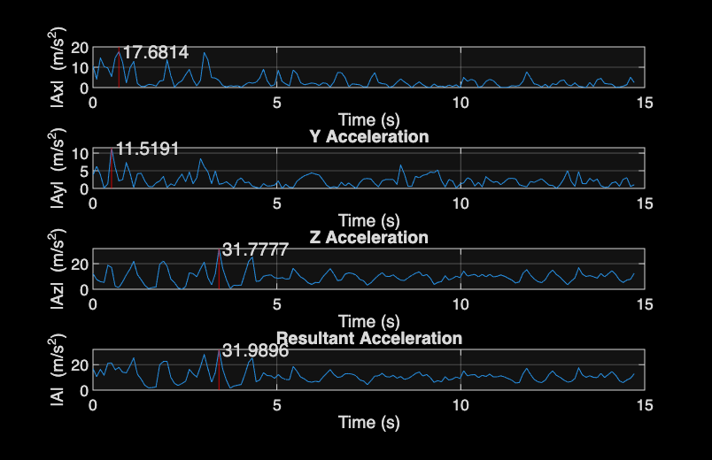

Part B) This question refers to Step 2 in the lab manual. Include below, the annotated plot produced from your partner’s data, and your partner’s name.

Leonardo Hernandez Santana’s Plot
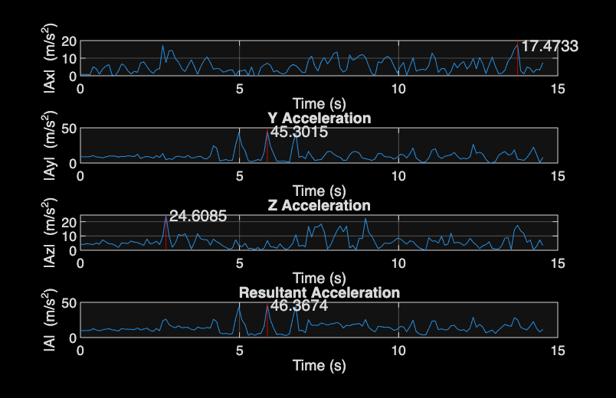

Question 3: AI Reflection
If you used AI for any aspect of your lab, you must complete a short reflection documenting your AI use. You must also attach a log (either as a text log, or screenshots) of your interaction with AI. Your log does not need to be exhaustive, but should provide a reasonable overview of your interaction with the AI: you should include the “important” questions you asked but can omit the complete text of the AI’s response and minor follow up questions. An example is provided on Canvas. Provide 1-3 sentences in answer to the following questions:

- Which AI tool(s) did you use? E.g. cursor, ChatGPT, Gemini, etc…
ChatGPT

- Describe how you used AI in your lab. E.g. to help with debugging, to suggest ways to improve efficiency/clarity of your code, etc…
In the lab2_manual, the step asked us to ask AI for some suggestions for my plot. And it gives me suggestions about using different colors for different accelerations, making red circles on each peak, spacing between each other, and so on.

- What steps did you take to verify that the responses given to you by the AI were good ones?
I tested the recommended MATLAB suggestions to confirm they worked correctly and improved the clarity of my plots. But after that, I make it originally, because I prefer to use the same color and have a degree of red-green color blindness.

Attach chat logs here
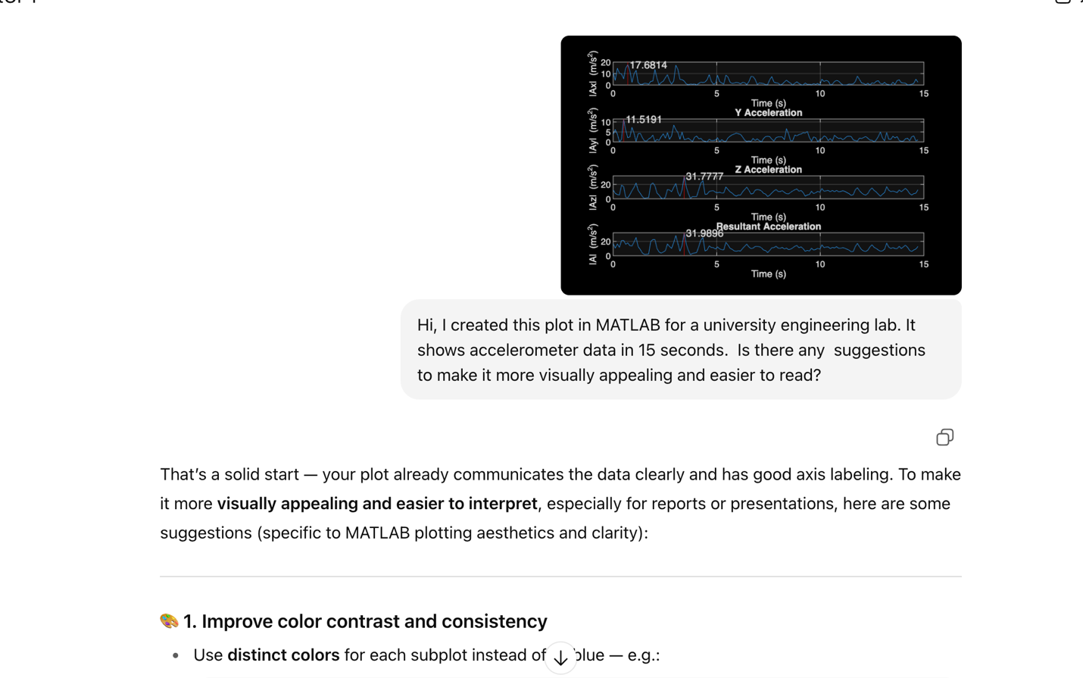
That’s a solid start — your plot already communicates the data clearly and has good axis labeling. To make it more visually appealing and easier to interpret, especially for reports or presentations, here are some suggestions (specific to MATLAB plotting aesthetics and clarity):

🎨 1. Improve color contrast and consistency
- Use distinct colors for each subplot instead of all blue — e.g.:
- colors = [0 0.4470 0.7410; 0.8500 0.3250 0.0980; 0.9290 0.6940 0.1250; 0.4940 0.1840 0.5560];
Then in each plot:
plot(t, abs(Ax), 'Color', colors(1,:), 'LineWidth', 1.2)
- Use a white background (set(gcf, 'Color', 'w')) to make it publication-friendly (the current black background is stylish but harder to read in print).

📏 2. Adjust layout and spacing
- Use tiledlayout(4,1,'TileSpacing','compact','Padding','compact') instead of subplot to reduce white space and better align axes.
- Add a shared x-axis label at the bottom:
- xlabel(tiledlayout_handle, 'Time (s)')
- Consider slightly enlarging fonts:
- set(gca, 'FontSize', 12, 'LineWidth', 1)

🔢 3. Highlight the peaks cleanly
- Use markers to show peaks more clearly:
- hold on
- plot(peakTime, peakValue, 'ro', 'MarkerFaceColor', 'r')
- text(peakTime, peakValue + 2, sprintf('%.2f', peakValue), 'Color', 'r', 'FontWeight', 'bold')
- You could also use a vertical line (xline) to mark where peaks occur for easier comparison across subplots.

📊 4. Add clear titles and consistency
- Keep titles consistent in format:
- title('X Acceleration (|A_x|)', 'FontWeight','bold')
- For the final subplot, consider:
- title('Resultant Acceleration (|A| = sqrt(Ax^2 + Ay^2 + Az^2))')

🧩 5. Optionally, smooth or normalize data
If the raw data are noisy, apply a light smoothing filter for visual clarity:
smoothAx = smoothdata(abs(Ax), 'gaussian', 5);
plot(t, smoothAx, 'Color', colors(1,:), 'LineWidth', 1.2)

✨ Example style summary
Here’s a concise way to summarize the best visual settings:
set(gcf, 'Color', 'w')
tiledlayout(4,1,'TileSpacing','compact','Padding','compact')

for i = 1:4
nexttile
plot(t, abs(A{i}), 'LineWidth', 1.3, 'Color', colors(i,:))
grid on
set(gca, 'FontSize', 12, 'LineWidth', 1)
end
xlabel('Time (s)')

Would you like me to show an example MATLAB code snippet that reproduces your current figure with these visual upgrades (keeping your data structure in mind)?

